If we have a separate variables.yml and different playbooks

vi variables.yml

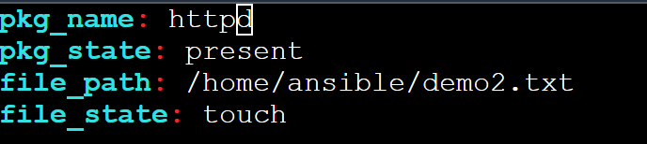

pkg_name: httpd

pkg_state: present

file_path: /home/ansible/demo2.txt

file_state: touch

vi playbook.yml

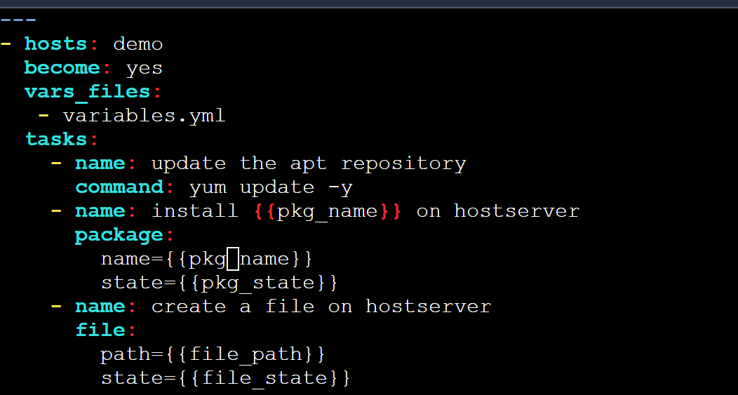

---

- hosts: demo

become: yes

vars_files:

- variables.yml

tasks:

- name: update the apt repository

command: yum update -y

- name: install {{pkg_name}} on hostserver

package:

name={{pkg_name}}

state={{pkg_state}}

- name: create a file on hostserver

file:

path={{file_path}}

state={{file_state}}

ansible-playbook playbook.yml